Ex. No. 5

**IMPLEMENTATION OF CLUSTERING ALGORITHM**

**Aim:**

To implement the k-Means Clustering algorithm for the dataset minute weather with scikit-learn in Python.

**Algorithm:**

1. Import necessary libraries:

- pandas

- seaborn

- sklearn

2. Data Loading and Exploration:

a. Read 'minute_weather.csv' into a DataFrame 'w_data' selecting columns: 'max_wind_direction', 'max_wind_speed', 'air_pressure'.

b. Display the first few rows of 'w_data'.

3. Data Visualization:

a. Create a scatter plot:

- x-axis: 'max_wind_direction'

- y-axis: 'max_wind_speed'

- hue: 'air_pressure'

4. Data Preprocessing:

a. Split the data into:

- Training set: X_train, Y_train

- Testing set: X_test, Y_test

b. Handle missing values:

- Replace NaN values in X_train and X_test with mean of respective columns.

- Replace NaN values in Y_train and Y_test with mean of 'air_pressure'.

c. Normalize the data:

- Normalize X_train and X_test.

- Normalize Y_train and Y_test.

5. KMeans Clustering:

a. Initialize KMeans with:

- n_clusters = 3

- random_state = 0

- n_init = 'auto'

b. Fit KMeans on normalized X_train.

6. Visualization of Clusters:

a. Create a scatter plot:

- x-axis: 'max_wind_direction'

- y-axis: 'max_wind_speed'

- hue: KMeans labels from X_train.

7. Visualization of Clustered Data and Air Pressure:

a. Create a boxplot:

- x-axis: KMeans labels from X_train

- y-axis: 'air_pressure'

8. Additional Visualization (Incomplete/Assumed):

a. Create a scatter plot:

- x-axis: 'max_wind_direction'

- y-axis: 'max_wind_speed'

- hue: Cluster labels from 'fits[0].labels_'

**Code:**

import pandas as pd

w_data = pd.read_csv('/content/minute_weather.csv' ,usecols=['max_wind_direction','max_wind_speed','air_pressure'])

w_data.head()

import seaborn as sns

sns.scatterplot(data=w_data, x='max_wind_direction', y='max_wind_speed', hue='air_pressure')

from sklearn.model_selection import train_test_split

X_train, X_test, Y_train, Y_test = train_test_split(w_data[['max_wind_direction','max_wind_speed']], w_data[['air_pressure']], test_size=0.33, random_state=0)

from sklearn import preprocessing

import numpy as np

X_train_clean = np.nan_to_num(X_train,nan=np.nanmean(X_train))

X_test_clean = np.nan_to_num(X_test,nan=np.nanmean(X_test))

X_train_norm = preprocessing.normalize(X_train_clean)

X_test_norm = preprocessing.normalize(X_test_clean)

Y_train_clean = np.nan_to_num(Y_train,nan=np.nanmean(Y_train))

Y_test_clean = np.nan_to_num(Y_test,nan=np.nanmean(Y_test))

Y_train_norm = preprocessing.normalize(Y_train_clean)

Y_test_norm = preprocessing.normalize(Y_test_clean)

from sklearn.cluster import KMeans

kmeans = KMeans(n_clusters = 3, random_state = 0, n_init='auto')

kmeans.fit(X_train_norm)

import seaborn as sns

sns.scatterplot(data = X_train, x = 'max_wind_direction', y='max_wind_speed', hue = kmeans.labels_)

import seaborn as sns

sns.boxplot(x = kmeans.labels_, y = Y_train['air_pressure'])

import seaborn as sns

sns.scatterplot(data = X_train, x = 'max_wind_direction', y = 'max_wind_speed', hue = fits[0].labels_)

**Output:**

air_pressure min_wind_direction min_wind_speed

0 912.3 96.0 1.4

1 912.3 80.0 1.3

2 912.3 70.0 1.2

3 912.3 60.0 1.1

4 912.3 30.0 1.0

<Axes: xlabel='min_wind_direction', ylabel='min_wind_speed'>

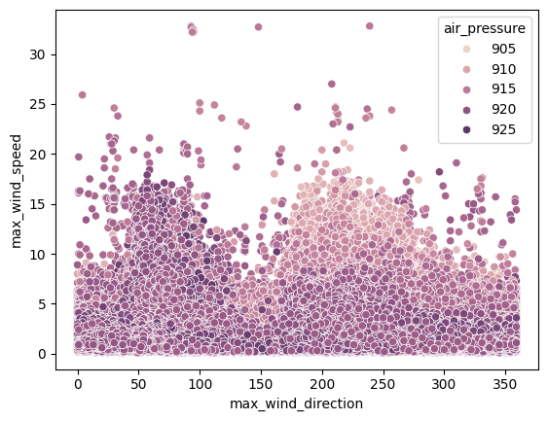

<Axes: xlabel='min_wind_direction', ylabel='min_wind_speed'>

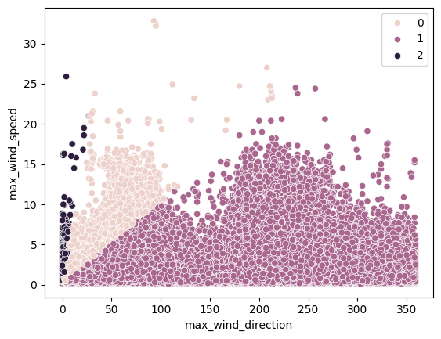

<Axes: ylabel='air_pressure'>

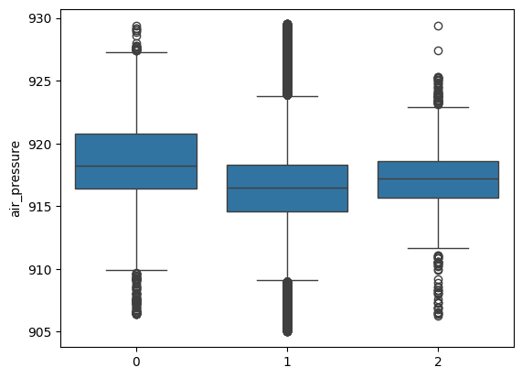

<Axes: xlabel='min_wind_direction', ylabel='min_wind_speed'>

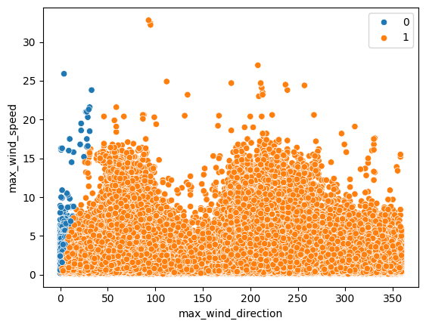

**Rubrics:**

|  |  |  |  |  |
| --- | --- | --- | --- | --- |
| **Problem**  **Understanding**  **(10)** | **Implementation**  **(20)** | **Viva**  **(10)** | **Time Management**  **(10)** | **Total**  **(50)** |
|  |  |  |  |  |

**Result:**

Thus the implementation of the k-Means Clustering algorithm for the dataset minute weather with scikit-learn in Python was successfully executed and he output was verified.